July 22, 2023|Minutes

## Meeting date | time July 22, 2023 | 1:06 pm CT | Meeting location Scotlandville Library and via Zoom

|  |  |  |  |  |  |  |  |  |  |  |  |  |  |  |
| --- | --- | --- | --- | --- | --- | --- | --- | --- | --- | --- | --- | --- | --- | --- |
| |  |  | | --- | --- | | Meeting called by | Angela White @ 1:06 pm | | Type of meeting | Regular Bi-Monthly Meeting / | | Presiding Officer | Angela White | | Secretary | Marquetta Cheeks | | Timekeeper | NA | | Prior Meeting Minutes Status | Approved | | Participants | William Augustine  Calvin Brown  Marquetta Cheeks  Tim Damon  Cheryl Hall  Betty Kiper  Rhea Kiper  Clifton P. Levy  Barbara Mills  Dr Joyce Polk  Dorothy Davis  Karen Rowe  Kenneth Simpson  Sam Smith  Eddie Veal  LaTasha Walker  Ann R. White  Angela D White  Claudia Wright |

# Agenda topics

## Time allotted | 5-10 minutes | **Agenda topic** Adoption of Agenda| Presenter Angela White

Discussion Meeting agenda was reviewed. Under Adjournment, the date for next meeting was corrected to August 19, 2023. Agenda was moved for adoption by Kenneth Simpson. Seconded by Joyce Polk.

**Agenda**

|  |  |
| --- | --- |
| * Call to Order * Prayer * Adoption of Agenda * July 22, 2023 Meeting Minutes Discussion / Approval * Officer Reports   + President’s Report   + Treasurer Report * Committee Reports   + Membership   + Activities   + Infrastructure | * New Business   + 2023 Proposed Budget   + Proposed Covenants, Codes & Restrictions Review / Discussion * Adjournment   + Next meeting date – August 19th |

Conclusion Meeting agenda approved by majority voice and zoom vote.

## Time allotted | 5 minutes | **Agenda topic** April 22nd Meeting Minutes Approval| Presenter Angela White

Discussion Attendees were solicited for any needed modification to the April 22, 2023 bi-monthly meeting minutes. No modifications were identified

Conclusion April 22 2023 SHPOA Meeting Minutes approved by acclamation.

## Time allotted | 5-10 Minutes| **Agenda topic** President’s Report | Presenter Angela White

Discussion

* **SHPOA complaint on SHCPID violations & request for full SHCPID Board replacement:**
  + Details on the issues and the timeline of SHPOA efforts to address SH resident’s complaints are in the April 2023 meeting minutes.
  + Prior activity in 2023 was listed on slide including the request to replace to the entire board; termination of SHPOA Commissioners on the SHCPID Board and request for materials.
  + At the last meeting, we discussed that the issues were referred to the LA Legislative Auditor for investigation. Updates on investigation include:
    - We have been notified that the LA Legislative Auditor has initiated an investigation.
    - Angela D White, SHPOA President had been interviewed and has provided requested documentation.
    - LA Legislative Auditor has referred the Open Meeting and Budget Act violations to the LA Attorney General.

Question raised by Eddie Veal about the reason for the complaint and whether the SHCPID patrols were not enough to satisfy residents. It was explained that details on the issues could be found in the April 23, 2023 SHPOA meeting minutes. Angela White briefly discussed the complaint, its history and the unresolved SHCPID issues:

* SHCPID was established in 2017 as a quasi gov’t agency. After review of complaints and an understanding of SHCPID operational requirements, resident communications and transparency complaints were outlined in 2021 to all SHCPID Board members including their failure to comply with the Local Gov’t Budget Act and the Open Meeting Law.
* SHPOA Officers met with Jesse Glasper, SHCPID President in 2021. At that meeting the discussion included the resident issues, SHCPID state law violations, newly created SHCPID bylaws that both conflicted with SHCPID legislation & lacked SH resident review, SHCPID failure to properly process Board requirements and Commissioner terms.
* Residents participated in a 2021 SHCPID meeting where the following occurred:
  + Jesse Glasper, SHCPID President, refused to discuss the issues raised in the SHPOA Officer meeting with the SHCPID Board.
  + SHCPID Board refused SHPOA’s request to conduct a crime and safety workshop for resident’s due to lack of funding, NOTE: SHPOA has held crime and safety workshops for the past 2 years.
* SHPOA Officers voted to investigate replacing the SHCPID Board in Sept 2022.
* Request sent to SHCPID Board to meet with SHPOA Officers in 2023. Jesse Glasper, SHCPID President refused to meet.
* To date, SHCPID has not resolved the failures and issues raised in 2021.
* **Traffic Study Request:** Petitions and request for Traffic Study for Southern Heights will be mailed on week of July 23, 2023. Prior issues with valid petition signatures per street were addressed for all streets in Southern Heights
* **Crime Statistics (2023 to date):** Crime statistics within Southern Heights and in high crime areas bordering Southern Heights were presented.
  + Crime reported within Southern Heights (34)
    - Was greatest in commercial areas with a total of 26 crimes reported to date (75%) at White Apartments on 78th, Red Apartments on 79th, Chevron, Sunoco, and Jaguar Plaza
    - A total of 8 crimes was reported within SFH residents (25%)
  + Crime reported in commercial areas near Southern Heights (51) with the greatest crime reported at Cadence Apartments (43) and McDonald’s / Harding Plaza (8).

Conclusion Actions to avert these higher crime statistics within commercial areas in SH and bordering Southern Heights need to be undertaken.

|  |  |  |
| --- | --- | --- |
| Action Items | Person responsible | Due Date |
| Propose actions to avert crime statistics within commercial areas in SH and bordering Southern Heights to be undertaken. | SHPOA Officers | Aug 19, 2023 |

## Time allotted | 5-10 minutes | **Agenda topic** Treasurer’s Report | Presenter Angela White for Sheila V Sims

Discussion The Treasurer could not attend the meeting but sent the Q2 quarterly report.

Our checking account has been moved to Neighbors Federal Credit Union to reduce service charges and to allow credit card payments by members. The saving account will be moved to Neighbors to reduce service charges in July. Our credit card capability has passed PCI compliance. The glitch in our credit card processing has been resolved. NOTE: we do not store any credit card numbers as part of our processing.

Residents should use the SHPOABR.COM website to complete their member information including emergency contacts and to indicate their planned dues payment (number of years and type of payment). You can pay from 1-4 years. Checks are accepted via the PO Box or drop off at 2146 78th Ave. Credit card payments will incur a 3% transaction convenience fee. Dues payment information, dues payment instructions and the link to pay via credit card are displayed in your membership confirmation message. You can also pay by credit card at our meetings and events.

The Q2 quarterly report detailed the deposits and withdrawals in the checking and savings account balances in Q2. Q2 checking accounts beginning balance was $1812.33. Deposits include ($275 (April) and $25.75 (June). Checking expenses paid this quarter were the $48 (one-time charge) to Fiserv (Clover Software), the bank approved software and service to handle credit card processing for dues and other member payments. Q2 Checking ending balance is $2,133.08

The savings account at Southern Teachers & Parents Credit Union had a beginning quarterly balance of $1,698.47. The saving account incurred a $5 quarterly share fee. The Q2 savings account ending balance was $1,693.47. Total funds across both accounts at the end of Q2 is $3,806.55.

Conclusion Tasha Jones moved to accept the Financials and motion was seconded by Joyce Polk. The motion to accept Q2 financials was approved without opposition.

## Time allotted | 5 minutes | Agenda topic Membership Report| Presenter Angela White

Discussion Membership statistics for 2020 and 2022 along with the goal for 2023 were displayed as follows:

|  |  |  |
| --- | --- | --- |
| Year | Membership  Goal | Actual Membership |
| 2021 | NA | 52 |
| 2022 | 100 | 74 |
| 2023 | 160 | 35 (to date) |

Membership is currently at 35 households. We are well below goal for 2023. Neighbors who are members are asked to solicit their neighbors.

Dues are currently set at $25 thought the amount needs to be raised.

We set our goal for 2023 at 160 based on the fact that we have 300 plus resident properties in Southern Heights.

Conclusion Efforts are needed to increase membership.

## Time allotted | 5 minutes | Agenda topic Activities Report| Presenter Angela White/Tasha Jones

Discussion

Proposed 2023 Activities include:

* Tidy UP Campaign – drawing for persons who submit their SH litter clean-up activity such as clearing litter from your lawn, street and storm and for clearing from your neighbor’s or a vacant lot.
  + Phase I - Anti Litter – Prize is a gift card from Clegg’s Nursery. Prize will be awarded at the bi-monthly meetings.
  + Phase II – Lot & Lawn Maintenance – Quarterly prize is a larger gift card from Clegg’s and recognition for best lawn of the quarter.
* SH/SHPOA Anniversary Banner (entrance). In celebration of the anniversaries of Southern Heights (70+ years)/ and the Southern Heights Property Owners Association (60 years), the committee proposed to erect a banner or signage to recognize the anniversaries for Southern Heights residents and the North Baton Rouge and Baton Rouge communities. It was determined not to do the SU homecoming parade due to cost & effort required.
* SHPOA Anniversary Celebration –Both Sept 23rd or Nov 4th or 18th are available (due to SU football schedule) for an anniversary celebration. More planning is needed for the anniversary activity/activities. NOTE: Interest in a reunion event, spurred by the Park Vista reunion event in 2022, has been expressed by persons who are no longer living in Southern Heights. Persons are interested in having an activity next year.
  + Cheryl Hall explained the Park Vista reunion was only a reunion for residents who lived on Balsam Street in Park Vista. It is planned to expand in upcoming years to additional streets in Park Vista.
* Christmas Social – Dec 16th

Joyce Polk moved to accept the Activities Committee’s recommendation for remaining 2023 activities. The motion was seconded by Ann White. The motion was approved by majority vote with one abstention.

Tidy Up! Southern Heights Anti-Litter Campaign was reviewed. Thanks to the residents who have been seen participating but have not logged their activity. Persons who need assistance logging in their activity can call 225-205-7566 for assistance.

Persons who have been reported picking up trash include Sheila V Sims, Angela White, Kenneth Simpson and Lynn Hubbard. Their names are in the July drawing. The drawing was not held due to meeting time but will be drawn at the next meeting.

Conclusion Persons are needed to join the Activities Committee to support activity planning, in particular the Anniversary activities and the Christmas Social.

|  |  |  |
| --- | --- | --- |
| Action Items | Person responsible | Due Date |
| Find residents to actively serve on the Activities Committee | SHPOA Officers | Aug 19, 2023 |
| Conduct drawings for the July & August Tidy Up! Anti-Litter Campaign at the Aug 19th meeting. | Activity Committee Chair. |  |

## Time allotted | 5 minutes | Agenda topic Infrastructure Report| Presenter Angela White

Discussion Infrastructure activities around Southern Heights were listed. Melvin Kelly has agreed to monitor neighborhood infrastructure issues with City-Parish government.

Two sinkholes are in process on 78th Avenue. Residents should check their properties, front and back for sinkholes and report them to 311.

Canal erosion has occurred behind homes on 79th Ave along Harding Blvd. The issue was reported over four months ago but the city has not addresses the issue. Melvin Kelly will monitor and track the results of this work order.

Eddie Veal mentioned that the city has not properly maintained the overgrowth in Monte Sano Bayou. Water levels are now increasing in the bayou during heavy rains. He has not reported the issue using 311.

Once you report your infrastructure, please follow up with the city. Also, provide the work order information to Melvin Kelly so we can track how the city is effectively addressing our issues.

Changes in garbage, recycling and trash collection being implemented on Sept 1st and actions to be taken now to avoid extra charges were discussed. Details on slides below.

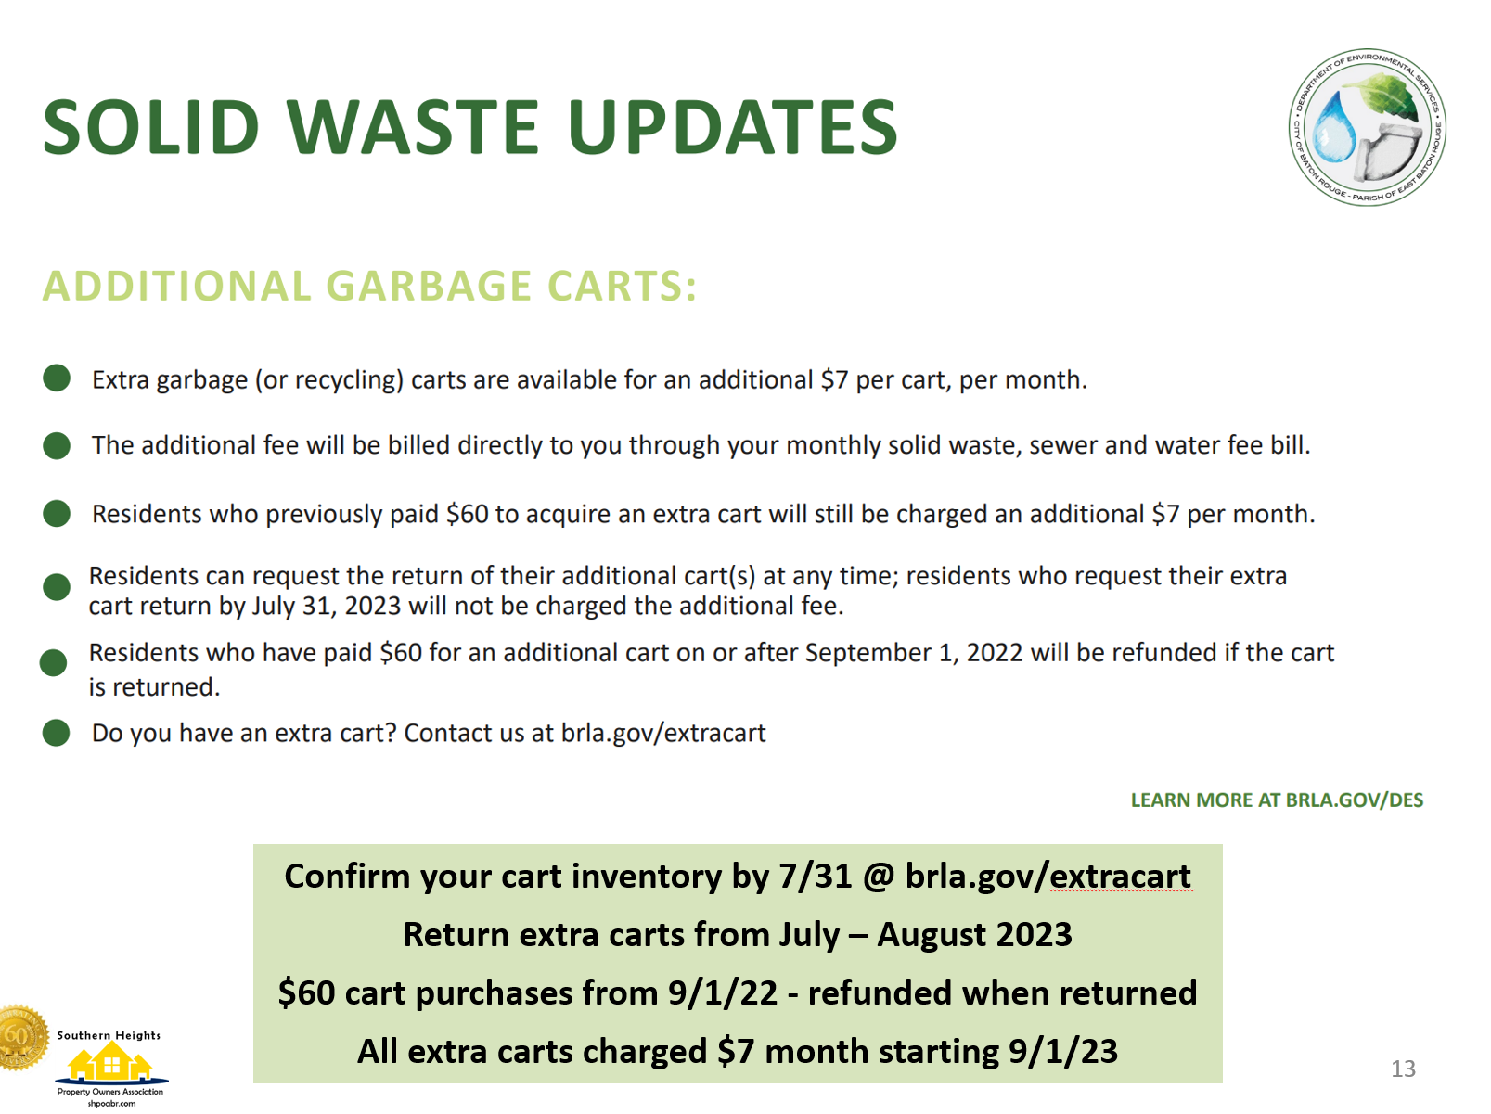

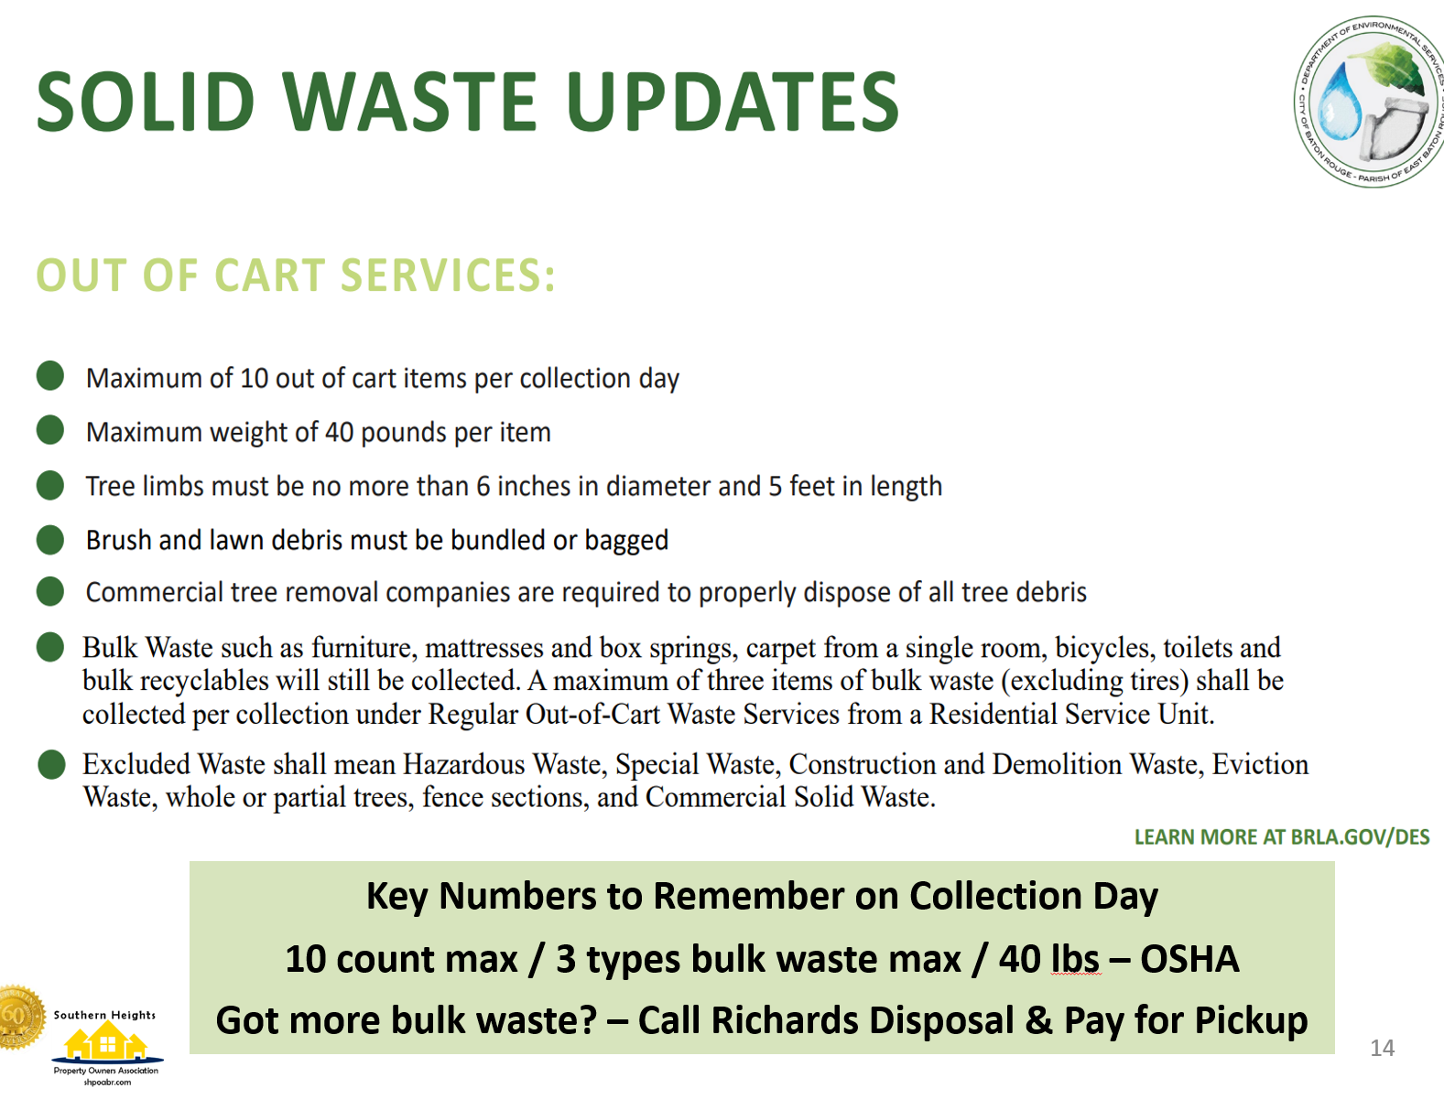

Conclusion NA

|  |  |  |
| --- | --- | --- |
| Action Items | Person responsible | Due Date |
| Residents should inspect their properties for sinkholes and other infrastructure issues and report them to the city using 311. | SH Residents | On going |
| Monitor the issue resolution with the City and report 311 infrastructure work orders to Melvin Kelly so we can monitor their resolution. | SH Residents, Melvin Kelly | On going |

## Time allotted | 5 minutes | Agenda topic Proposed 2023 Budget| Presenter Angela White for Sheila V Sims

Discussion Our opening balances for the year was $2,759.46 in checking and $1,693.09 in savings. Our finds are limited and we need to increase our membership, raise our dues and/or have fundraisers to support SHPOA.

Last year our membership goal was 100 members with actual membership at 74 households. We set a large stretch goal of 160 this year. Even with 160 members, our dues of $25 does not fully fund our anticipated organizational needs.

The proposed budget is below. Specific details are outlined after the budget. The proposed budget total is $7,573.11.

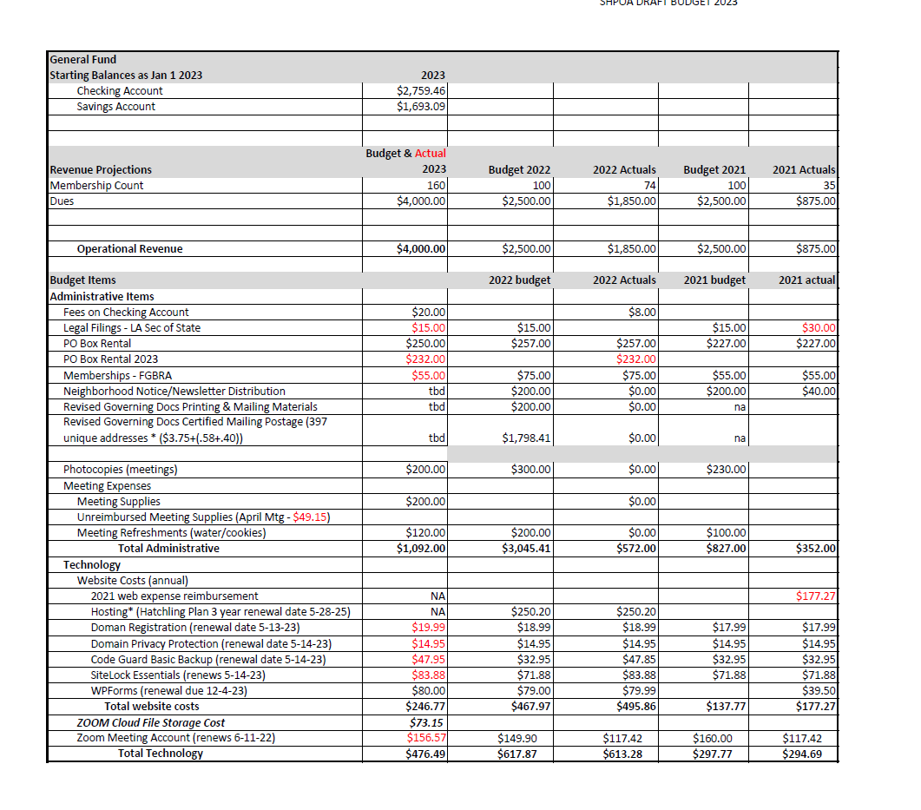

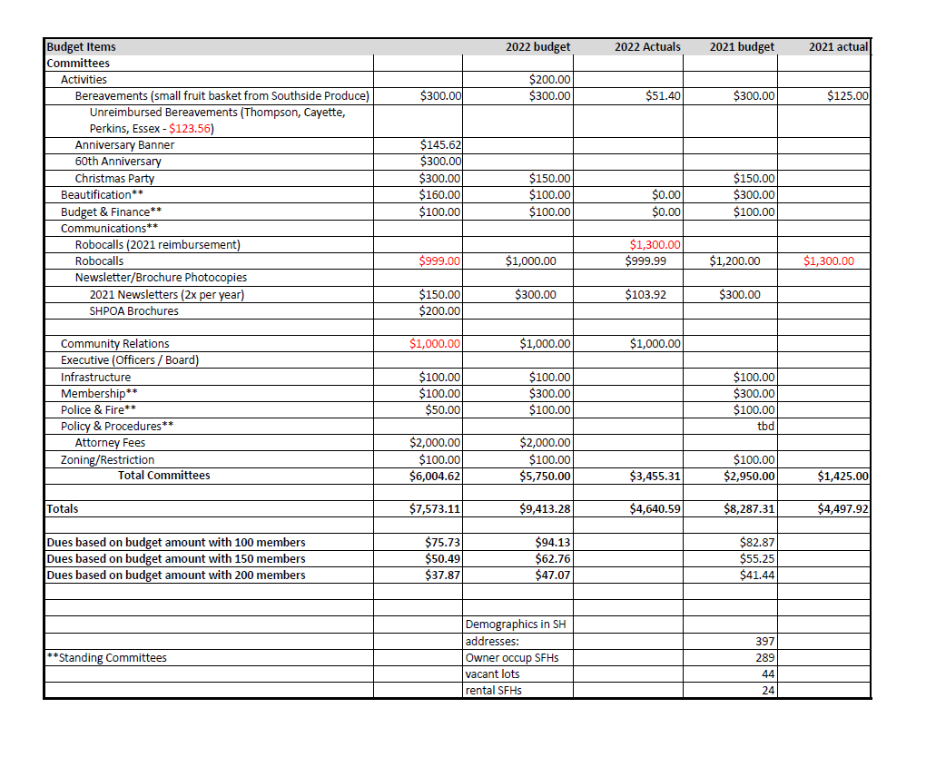

NOTE: Items in red are recurring expenses that have been paid (including items paid but not reimbursed by SHPOA).

**Administrative Line Items** include banking fees charged by Southern Teachers & Parents Credit Union, Fees for annually registering the organization at the LA Secretary of State, PO Box rentals (which are paid in the prior year to avoid the January standard rental fee increase), Federation of Greater Baton Rouge Civic Assn membership, meeting expenses for photocopies and supplies for in person meetings. Items not included in this year’s budget are fees for door to door distribution of any SHPOA newsletters (based on more electronic distribution via website, emails and text messages) and fees for mailing revised governing documents to all property owners (based on unknown / anticipated timing for voting or signing for ratification of governing document changes).

**Technology Line Items** include annual website infrastructure and hosting expenses ($246.77) as well as Zoom account and cloud meeting storage expenses.

**Committee Line Items** include minimal allocations for the **Budget & Finance, **Police & Fire. **Membership and **Infrastructure & Zoning Committees. Other committees have more defined budgets based on their specific and needs activities. The **Activities Committee proposed budget is based on the activities adopted in the July 22nd SHPOA meeting but more detail is needed. The **Beautification Committee budget includes monies for the Tidy Up! Campaign for the bi-monthly recognition & award in the neighborhood anti- litter campaign and the quarterly recognition & award for best lawn/yard (adopted via Activities Committee recommendations in the July 22nd meeting). The **Communications Community includes funds for our Robocalls system (used to communicate to SHPOA residents) and photocopies for twice yearly newsletters and the newly developed [SHPOA brochure](https://shpoabr.com/wp-content/uploads/2023/06/SHPOA-Brochure-v2.pdf). Community Relations Committee budget line item includes monies for our annual Bronze Sponsorship for the Krewe of Oshun Mardi Gras Parade and Festival. The **Policy & Procedures Committee budget includes funding for legal fees to finalize changes in the SHPOA Governing Documents (By-laws and the Covenants, Codes & Restrictions (CCRs) documents) and any legal fees that may be incurred to address SHPOA complaints with the SHCPID governance and operations. NOTE: Double asterisks (**) identify SHPOA standing committees. More details on each Committee can be found on the SHPOABR.com.

**Dues.** A discussion on raising dues surfaced during the proposed budget review. Cheryl Hall recommended that a more realistic approach would be to set the 2023 dues amount based on the approved budget amount divided by the number of 2022 members plus 10. Paul Levy was concerned that while dues have not been raised in 30 years that any increase in dues would reduce the number of residents willing to pay dues. Ann White indicated that if dues have not been raised for 30 years, it is not reasonable to expect SHPOA to operate today without a dues increase. Joyce Polk raised concern that the majority of property owners who rent their homes do not pay dues. Additional challenges include new neighbors who have not previously lived in an organized neighborhood, lack of an active membership to increase membership and non-paying residents gaining benefits from the Robocall system. NOTE: SHPOA has not removed non-members from the Robocall System since every household participates in the SHCPID via property taxes and we issue the safety and crime alerts.

It was moved and seconded to table the discussion on increasing membership to the August 19th meeting.

Conclusion The proposed budget and any decision on establishing the dues amount for 2023 will be discussed and decided in the August 19th meeting

|  |  |  |
| --- | --- | --- |
| Action Items | Person responsible | Due Date |
| The proposed 2023 budget will be discussed for adoption at the August 19th SHPOA meeting. | SHPOA Members | August 19, 2023 meeting |
| 2023 dues will be determined in the August 19th meeting | SHPOA Members | August 19, 2023 meeting |
| The discussion and decision on actions SHPOA should take to increase membership will be moved to the Aug 19th meeting. | SHPOA Members | August 19, 2023 meeting |

## Time allotted | 5-10 minutes | **Agenda topic** Proposed Covenants, Codes & Restrictions | Presenter Angela White

Based on the limited time in the meeting, the agenda item to discuss and make a decision on a subset of the Proposed Covenants, Codes and Restrictions could not be addressed.

ConclusionIt was moved and seconded to table the Proposed Covenant, Codes and Restrictions revisions discussion to the August 19th meeting.

|  |  |  |
| --- | --- | --- |
| Action Items | Person responsible | Due Date |
| The Proposed Covenant, Codes and Restrictions discussion/decision will be tabled to the  August 19th SHPOA meeting. | SHPOA Members | August 19, 2023 meeting |

## Time allotted | 2 minutes | **Agenda topic** Adjournment | Presenter Angela White

Conclusion Meeting adjourned at 2:20 pm.